

**Table of content**

|  |  |
| --- | --- |
| Introduction | …Page 1 |
| Objective | …Page 1 |
| Planning | …Page 2 |
| System Requirements | …Page 3 |
| Analysis and Implementation | …Page 4 |
| Output | …Page 7 |
| Challenges faced | …Page 12 |
| Resources | …Page 12 |

**Introduction**

The hospitality industry is a broad [category of fields](https://en.wikipedia.org/wiki/Industry_(economics)) within the [service industry](https://en.wikipedia.org/wiki/Service_industry) including [lodging](https://en.wikipedia.org/wiki/Lodging), [food](https://en.wikipedia.org/wiki/Food_service) and [drink](https://en.wikipedia.org/wiki/Drinking_establishment) service, [event planning](https://en.wikipedia.org/wiki/Event_planning), [theme parks](https://en.wikipedia.org/wiki/Theme_parks), [travel](https://en.wikipedia.org/wiki/Travel) and [tourism](https://en.wikipedia.org/wiki/Tourism). It includes hotels, cruise ships, tourism agencies, restaurants and bars.

This report is based on my web design programming final project website named “Voyegers.com, which is about a travel agency which provide Spaceships to travel through space like cruise ships in the sea. The concept and information are made up and fantasy based for the purpose of website. This website is only for educational purpose.

**Objective**

The goal was to make a website using HTML, CSS & JavaScript knowledge I have learned through this semester web design programming course. Focusing on the topic given by the teacher I wanted to make something unique. Human have been always voyagers. Our ancestors traveled the seas to find lands through this planet earth and we hope our future generation will be able to voyage among the space beyond this planet and solar system. Imaging that situation already existed, I build my website for a company named voyagers.com who provide spaceships for space recreation.

**Planning**

1. Selecting a topic that represent hospitality industry, Spaceship selected.

2. Make a five page website showing the services the trip provide and how customer can access them.

A home page to describe about the agency

A page to describe the spaceship teams.

A page to show the slide of the spaceships and their facilities.

A page to book trip online and search trip from data table.

A page to query and contact the agency.

3. using a table, form, list, image and link in that process.

4. Choosing color and shapes through CSS to properly design it.

5. Creating action for button, slider, ShowTime and a custom alert for “read copyright” using JavaScript.

6. Making a report and PPT based on the website and keep the design lasting on them too.

**System Requirements**

|  |  |
| --- | --- |
| Personal Computer  (used) | Processor: Intel® Core™ i7  System: 64-bit  OS: windows 10 pro  Memory: 8.00 GB  Version control: GIT  Browser compatible: Edge, chrome, opera, Firefox, (safari won’t support some feature) |
| HTML | html5 |
| CSS | css3 |
| JAVASCRIPT | Functional, vanilla, ES6 |
| Code editor | visual studio code |
| Images | Open source |
| Fonts & icons | Font-awesome, google fonts |
| Report & PPT | Microsoft Office 365 |

**Analysis and Implementation**

|  |  |
| --- | --- |
| Analysis | Implementation |
| index.html /home page  navigation bar to access all five html page  link every index page using hyperlink tag  link the style.css stylesheet  a back-ground picture featuring local-time and welcome message and query and register button  a container showing a picture and article about the agency set alert for the buttons  footer showing copyright  link necessary .js files with script tag | Html  Using list to create the navigation bar, section for the background image and container for the box and others usual.  CSS  Property: display, alignment, hover, border, position, font family, color, margin, class, id, child selector etc. /style.css  JS  function to show local time/crntTime.js  using getElementbyId & addEventListner to create alert/ main.js |
| teams.html  navigation bar to access all five html page  link the style.css stylesheet  link every index page using hyperlink tag  three div to show the team images and member list  button to slide previous and next images and read more  footer showing copyright  link necessary .js files with script tag | Keep the navigation bar from index.html  Html: three div to put picture and list about the team order-unordered both list used  CSS: same properties as index.html more or less/style.css  JS: create image slider using function and if statement/prenext.js |
| facilities.html  navigation bar to access all five html page  link the style.css stylesheet  link every index page using hyperlink tag  Auto image slider to show the spaceship picture  Three Boxes to show the facilities they provide  footer showing copyright  link necessary .js files with script tag | Keep the navigation bar from index.html  Html: section, radio button, img tag to create the auto slider  Three div ‘s to create the box container order-unordered both list used  CSS: same properties as index.html more or less/style.css  JS: create auto image slider using function and if statement/slider.js  using getElementbyId & addEventListner to create alert for buttons |
| booking.html  navigation bar to access all five html page  link every index page using hyperlink tag  link the style.css stylesheet  A trip booking form with form items like date submit, input, button etc.  A data table to search and show details about trips  footer showing copyright  link necessary .js files with script tag | Keep the navigation bar from index.html  Html: section, div, form, table, input, button etc.  CSS: same properties as index.html more or less/style.css  JS: using array and conditional statement to search and sort table/table.js |
| contact.html  navigation bar to access all five html page  link every index page using hyperlink tag  link the style.css stylesheet  link to open another tab finding location  Send message form  footer showing copyright and “read copyright” button to show custom alert about copyright disclaimer  link necessary .js files with script tag | Keep the navigation bar from index.html  Html: section, div, form, Link, input, button etc.  CSS: rties as index.html more same prope or less/style.css  Icons  JS: accessing window.alert and create custom alert with conditional statement and importing data from document body |
| Font Family | Google fonts imported  Do Hyeon, sans-sherif |
| Icons | Font-awesome imported |

**Output**

**Form**

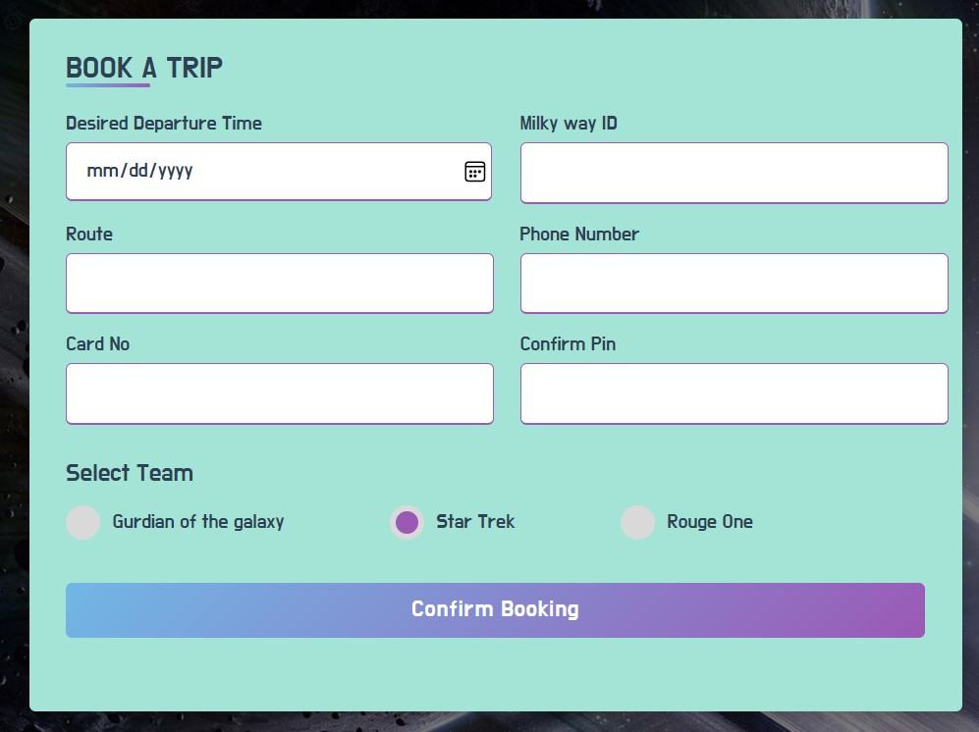

**Table**

**SEARCH**

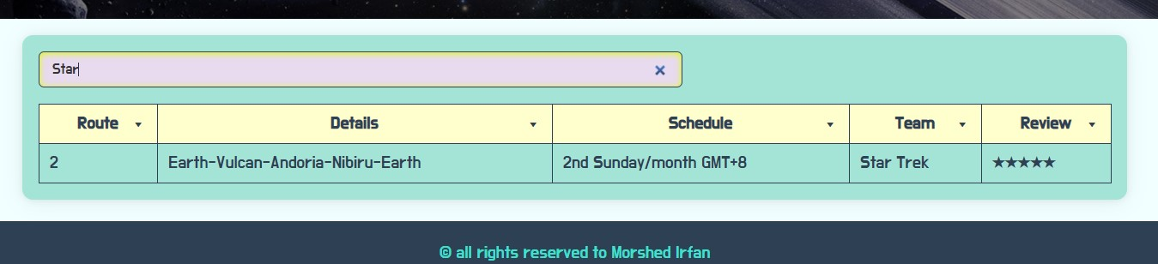

**SORT**

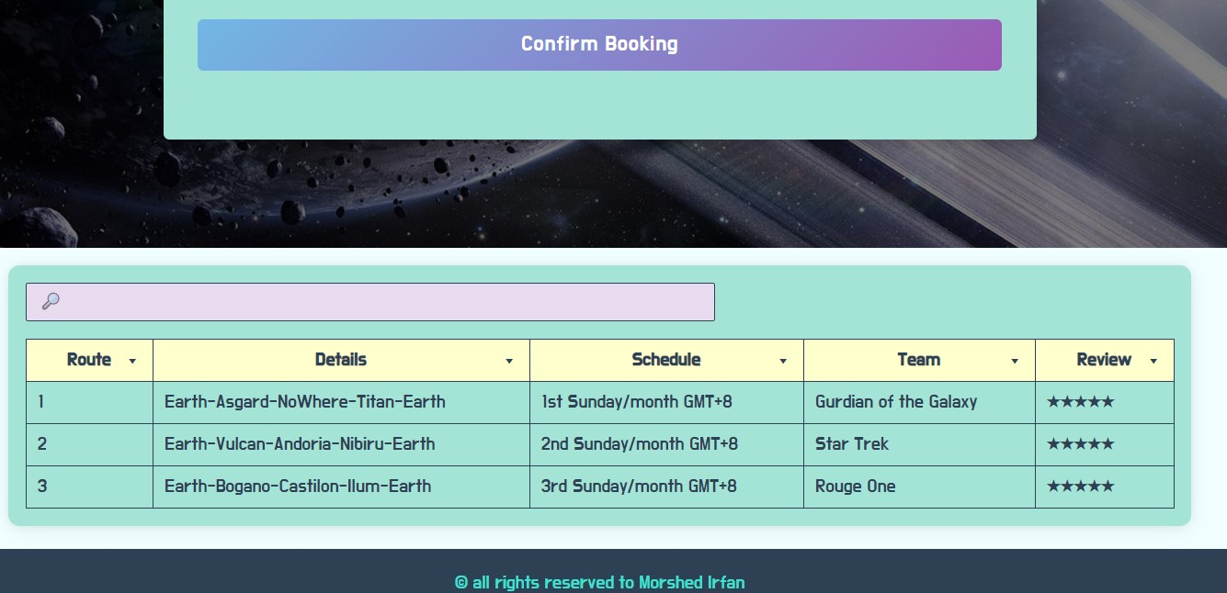

**Image Slider**

**SLIDER**

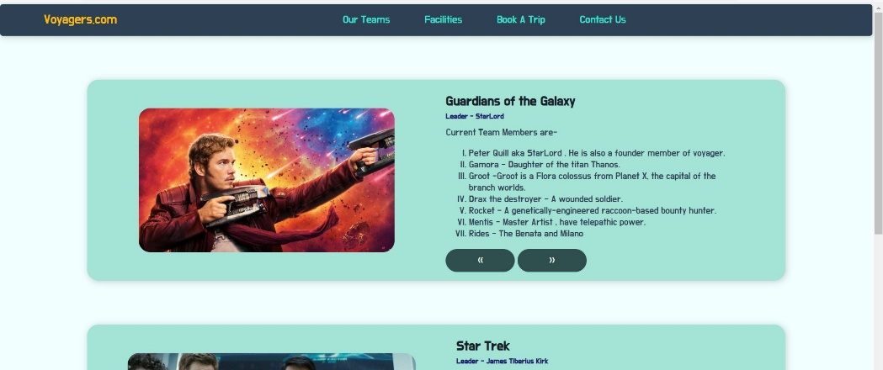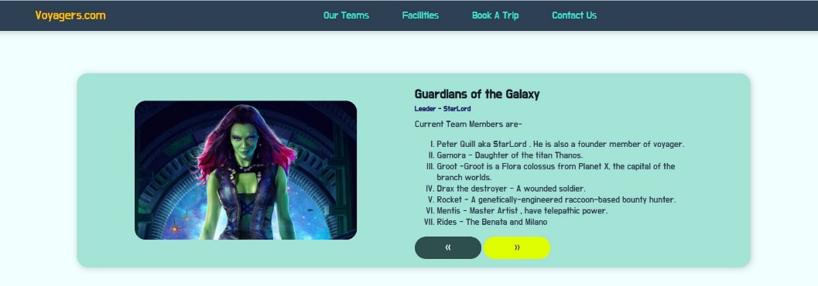

**AUTO SLIDER**

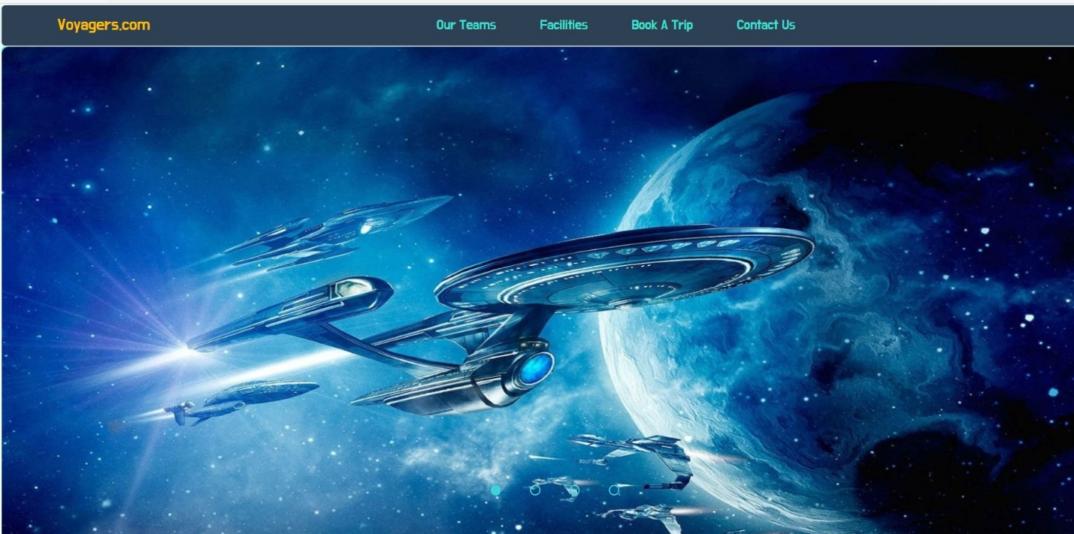

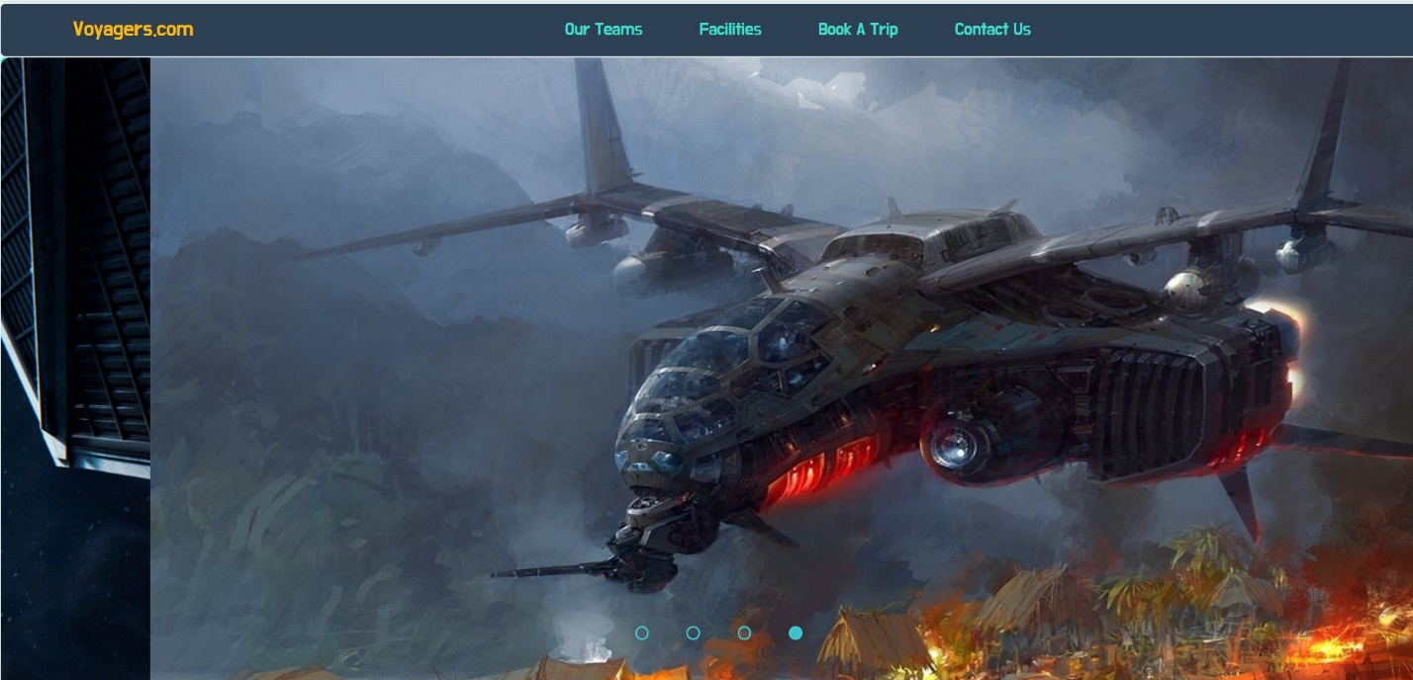

**List**

**ORDER AND UNORDERED**

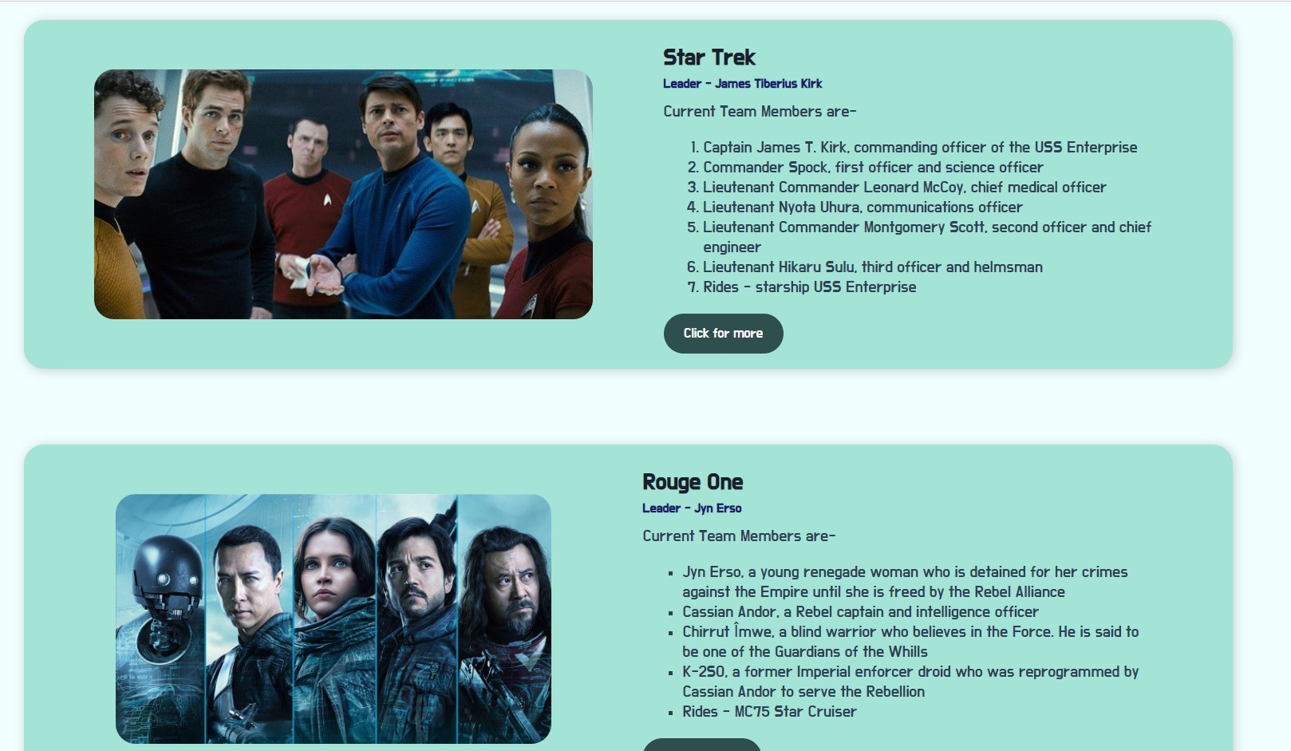

**Link**

**LOCATION**

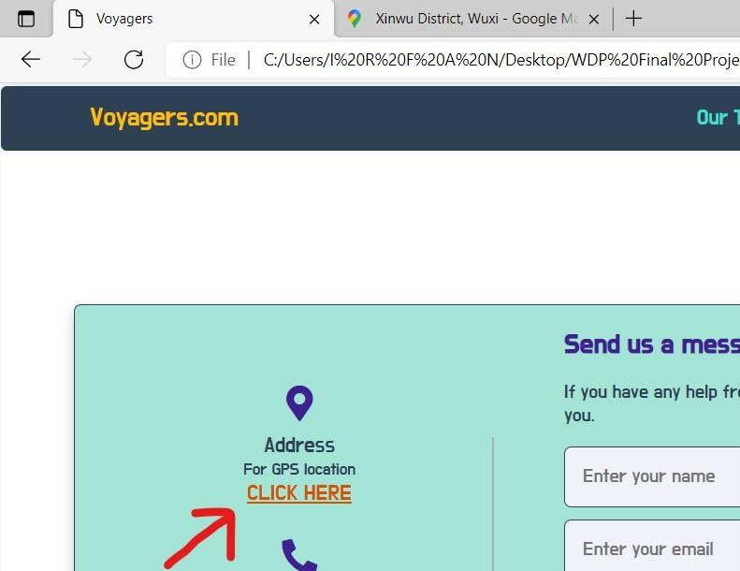

**CUSTOM ALERT**

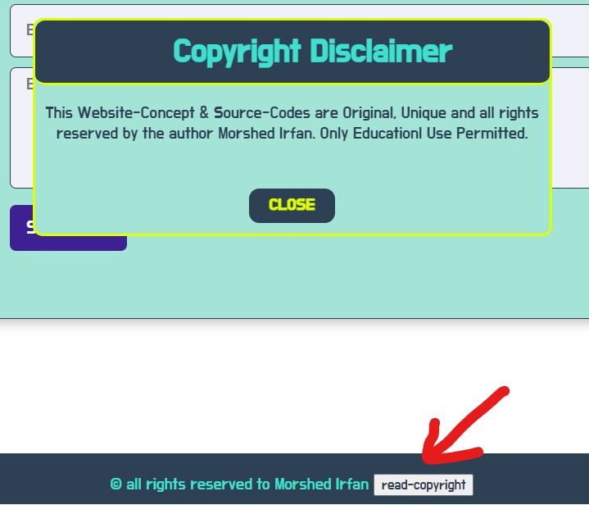

**BOX CONTAINER**

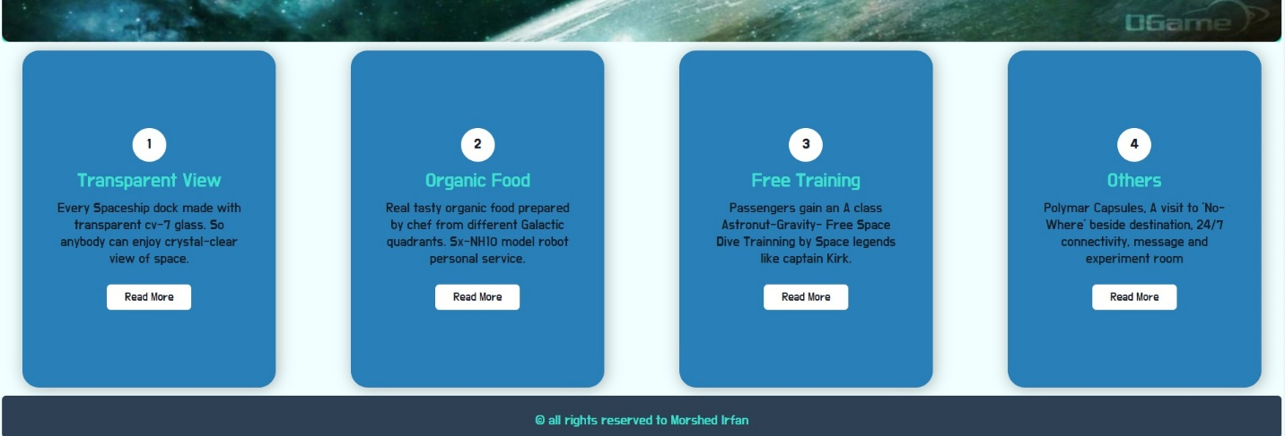

**Challenges Faced**

|  |  |
| --- | --- |
| **Challenges** | **Result** |
| Using Icons | solved |
| Making custom alert | solved |
| Making website responsive | Couldn’t solve |
| Making navigation bar position sticky | Couldn’t solve |
| Image slider & Auto image slider | solved |
| Using one main.js file for all functions | Couldn’t solve |
| Table sort & search option | solved |

**Resources**

* Lecture Video, PPT and PDF files from course Teacher
* https://www.w3schools.com
* https://developer.mozilla.org